E-Portal

To: [Edmond Hajrizi]
[Mondy COM]

Date: [21/07/2021]

For: Projekti do perfshije fushen e gazetarise, pra do jete nje portal online apo ndryshe E-Portal

Domain Name: http://eportal.megaterm-ks.com/

Web Hosting: https://uk.godaddy.com/

Domain Email: dionkuka@eportal.megaterm-ks.com

Static Pages: Me shume se 12 faqe.
Realisht ne webfaqen tone ndodhen 24 faqe per arsye qe cdo faqe eshte ne dy gjuhe shqip dhe anglisht.
Faqet qe gjenden ne webfaqe jane:
- Lajme
  - Shqiperi
  - Maqedoni
- Sport
  - Futboll
  - Basketboll
- Euro 2020
- Roze
  - Muzike
  - TV/Film
- About Us
- Contact Us
- Menu per ndrrimin e gjuhes

Design/Code: Webfaqja eshte krijuar me wordpress, me theme falas qe e ofron wordpressi I quajtur Twenty Twenty. Webfaqja eshte me dizajn te thjesht dhe shume user friendly dhe poashtu eshte responsive qe do te thote mund te perdoret edhe nga telefonat.

Usability: Webfaqja eshte shume e leht per tu perdorur, eshte shume user friendly dhe permes webfaqes mund te njoftohemi me lajmet me te reja.

Dynamic Apps: Features te kesaj webfaqe jane:
- Njoftimi me lajmet me te reja
- Leximi I lajmeve ne dy gjuhe
- Chat box per pyetje nga perdoruesit
- Recaptcha per sigurine me te madhe
- Contact Form per te na derguar ndonje email

Testing: Testimi I webfaqes eshte kryer me sukses duke u testuar ne cdo lloje ekrani si telefonet smart, kompjuteret me ekran te madh dhe te vogel, tablet etj.

Site Statistics: https://analytics.google.com/analytics/web/?fbclid=IwAR2melBrEVp4VFeBmrLa6FbfgaYotEv2O56QqtSDSBoUv05STWhqsfWOIF0#/report-home/a202569794w279732835p247302453

Costs: Web development fee: $[NUMBER].

Web hosting fee (a separate charge ) will be $[NUMBER] for the first year plus a $[NUMBER] setup fee.

Going forward, [COMPANY] will continue to be invoiced for web hosting charges once a year by [STUDENT GROUP]. LLLLLLLLLLLLLL

Payment Terms: One-third of total web development fee invoiced and due before work begins. A second one-third as well as the web hosting charge invoiced when page design templates are completed. Balance, adjusted for any changes, invoiced upon delivery of working application. All invoices are Net 10 Days.

Change Orders: The addition of pages or significant functions or features not specified here may result in additional costs; [STUDENT GROUP] will make this clear via Change Orders.

Contract: A standard Agreement and Specification will be provided upon verbal acceptance of this estimate.

This estimate is good for 60 days from the date above.

Schedule: Work will begin within one week of signing of contract and receipt of deposit payment. Approximately [NUMBER] weeks will be required from start to finish, assuming that the processes of providing content, feedback, and approval are free from delays.

Future Updates: [DESCRIBE DETAILS OF AVAILABILITY AND BILLING ARRANGEMENTS FOR POST-LAUNCH MAINTENANCE]

ANNEX 1

TERMS OF REFERENCE
TITLE: Design and development of the company website

Company: ______________________________

Group: ______________________________

Scope of service`

Group should start the project by analyzing client’s and documenting client requirements, to continue in exchange of ideas with the client in order to design the right structure for building the company's web site.

The design and development of the company website will be based on Content Management System, thus enabling representative staff to manage and edit website content. Further, training will be provided to representatives in regards to system usage.

As such, the project will be implemented in three phases detailed below:

Design and development of the company website
- Domain name registration and Hosting, which will be use for the purposes of the web site.
- (find the right hosting packet and available domain name)
- Designing and slicing based on the client's requirements presented by the mockups and based on company identity such as (logo, font and color).
- 2 mockups/wireframe per student
- Integrate the structure of the website in CMS

  - Structure of the company website
- Home page
- Static pages: minimum 5 up to 10
- Dynamic Pages: minimum 1 up to 5
- Functions:
Online application form
Vacancies
Photo or Video gallery
- CMS administration section

  - Multi language implementation (Albanian and German/English)

Warranty and maintenance

Warranty and web application maintenance includes: 12 months.

Wireframe [2 wireframes for each student on the group] 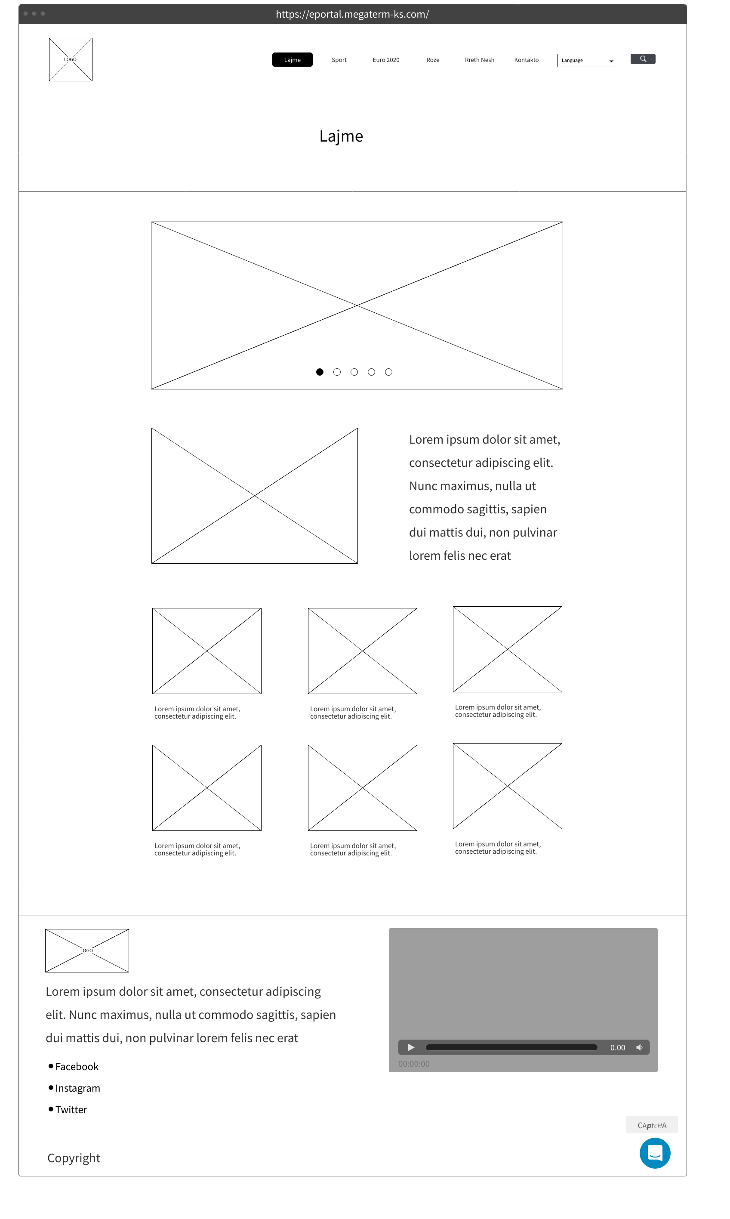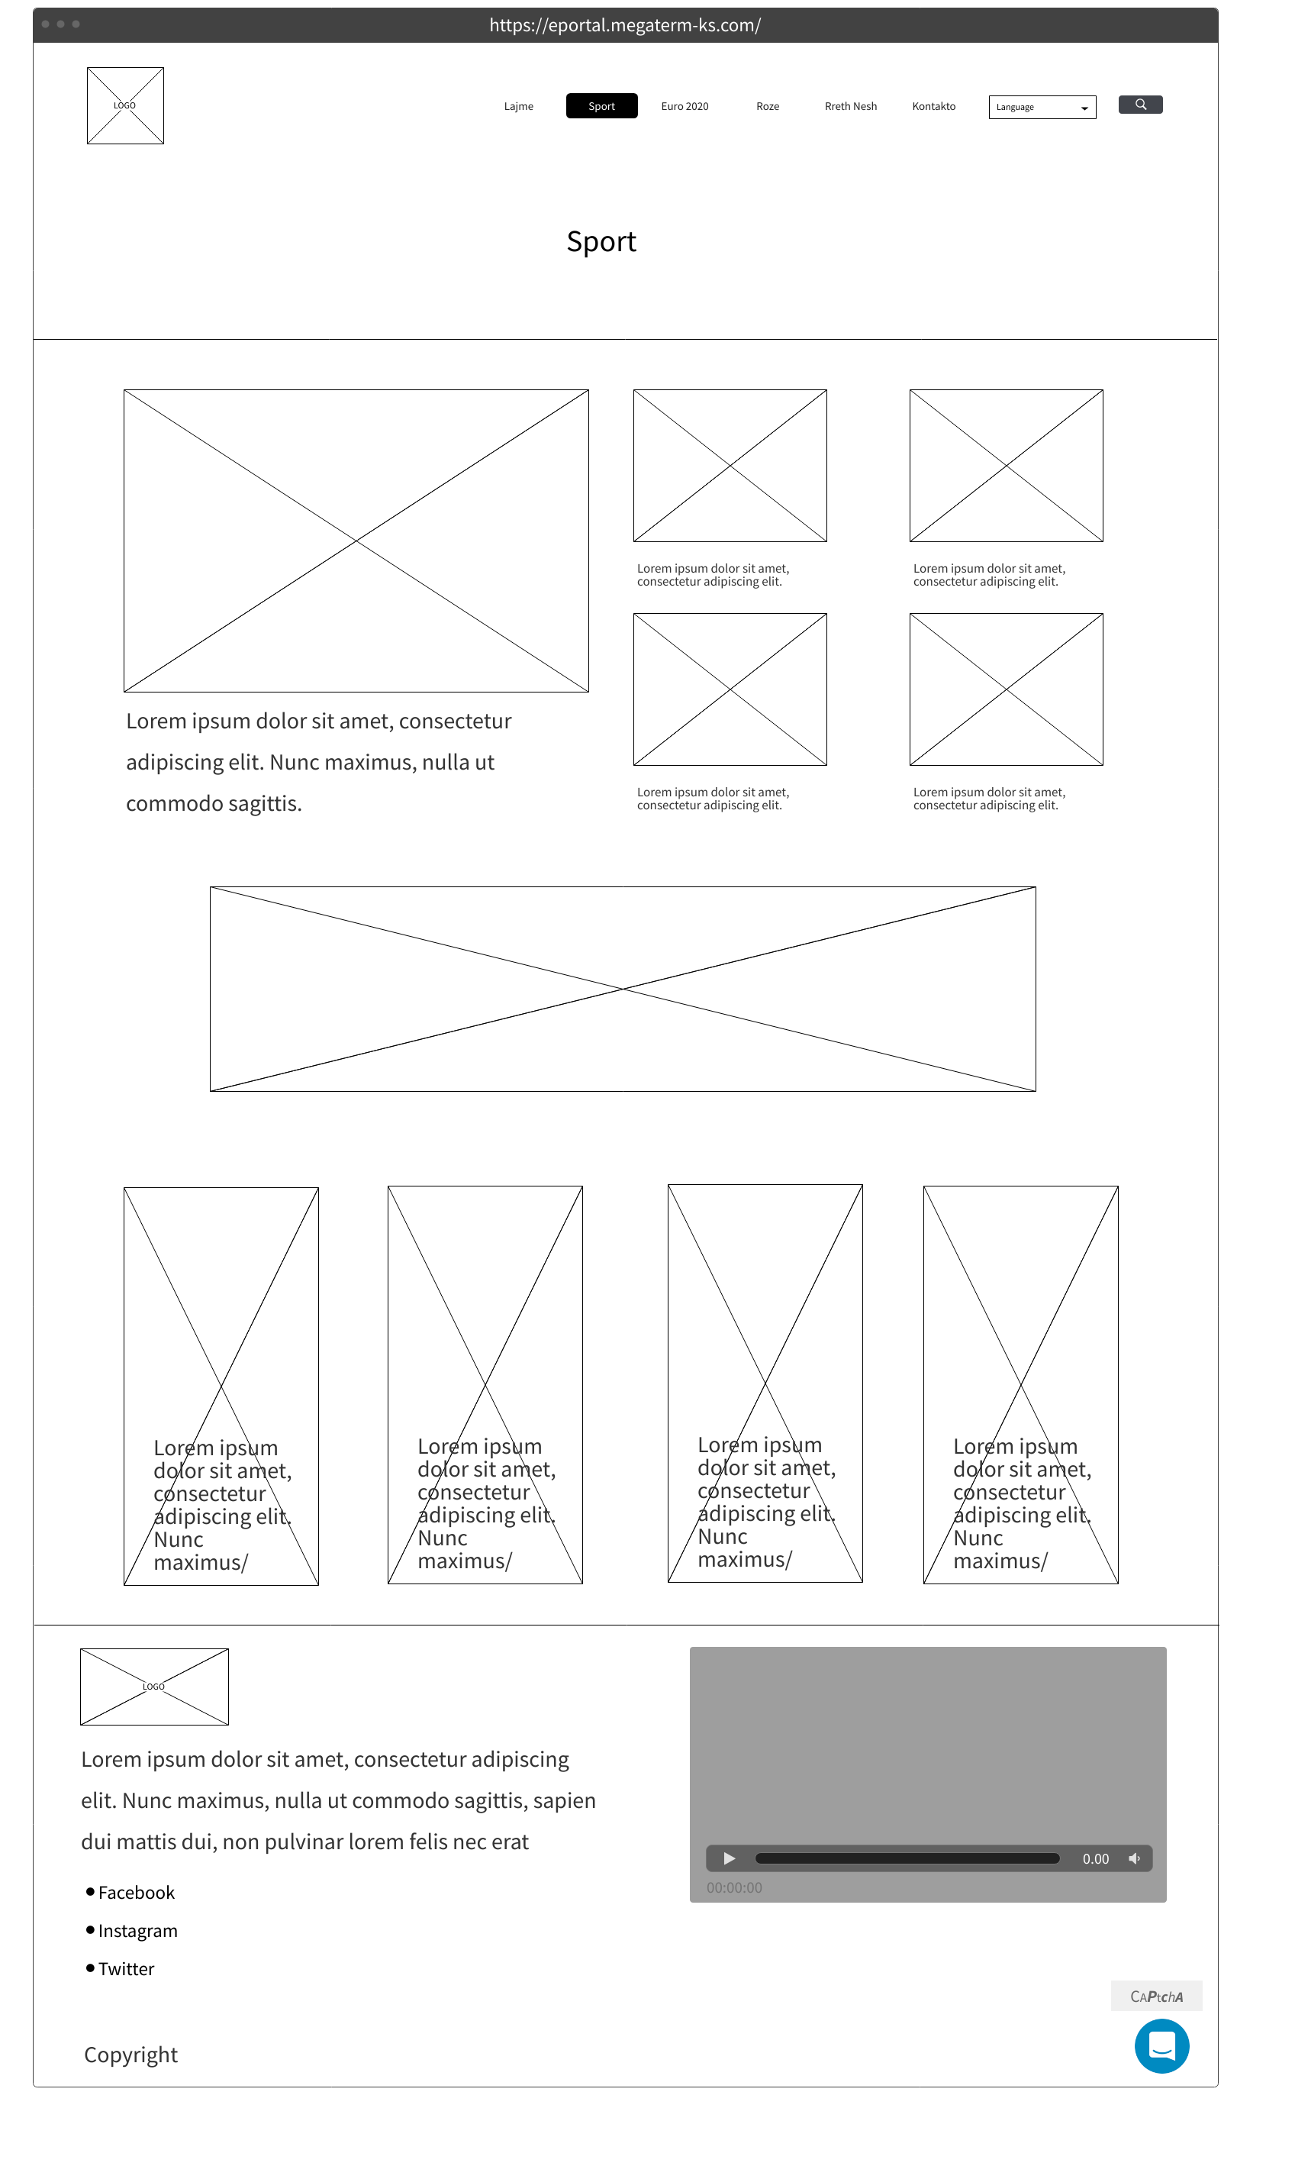

Final website print-screens
[print screen of domain availability, print screen of hosting packet with settings, List of website print screens,]

